**2023-2024 ACADEMIC YEAR 30 AĞUSTOS SECONDARY SCHOOL**

**2nd TERM 1st READING &WRITING ENGLISH EXAM**

**Name-Surname:**

**Class:**

**No:**

**A-Invite your friends to your birthday party. Fill in the blanks in the invitation card.** (Arkadaşlarını doğum günü partine davet et. Davetiyedeki boşlukları kendi doğum günü bilgilerinle tamamla.)



4

3

2

1

1

Love,

………………………………

DEAR……………………

**B-Write the correct words under the pictures. (Tv programlarının türlerini resimlerin altına yazınız.)**

**horror film - sports programme - the news - sitcom - sci-fi movie**

**cartoon - quiz show - talk show -**

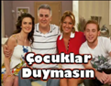



1)………………………………… 2)…………………………………. 3)………………………………….. 4)……………………………..

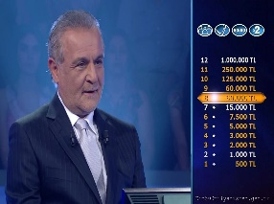

5)…………………………… 6)………………………………….. 7)…………………………… 8)…………………………………

|  |
| --- |
| **Fancy Dress Party** |
| **Wedding Party** |
| **Surprise Party** |
| **Christmas Part** |
| **Slumber Party** |
| **Birthday Party** |
| **Graduation Party** |

**C-) Write the party names under the pictures. (Partilerin adlarını altına yazınız)**

 

1-…………………………………………………… 2-………………………………………………..

  

**3-……………………………………………… 4-………………………………………………… 5-………………………………………………**

** **

**6-……………………………………………………….. 7-………………………………………………..**

**D-Answer the question.(Soruyu cevaplar mısınız? )**

1. **What do you need for a party? (Bir parti için nelere ihtiyacın vardır?)**

**1-…………food and drinks……..**

**2-………………………………………………**

**3-……………………………………………….**

**4-………………………………………………**

**5-………………………………………………**

**NOTE: Each question is 4 points.**

**GOOD LUCK 😊**

**Fatma YILDIZ**

**English Teacher**